Chapter 24.1.2, 24.2.1 and 2, 24.3.1 and 2.

In my case, I have to use a 1M ohm resistor works perfectly to get close to 3V output a 100K ohm would also work. 10K seemed too small.

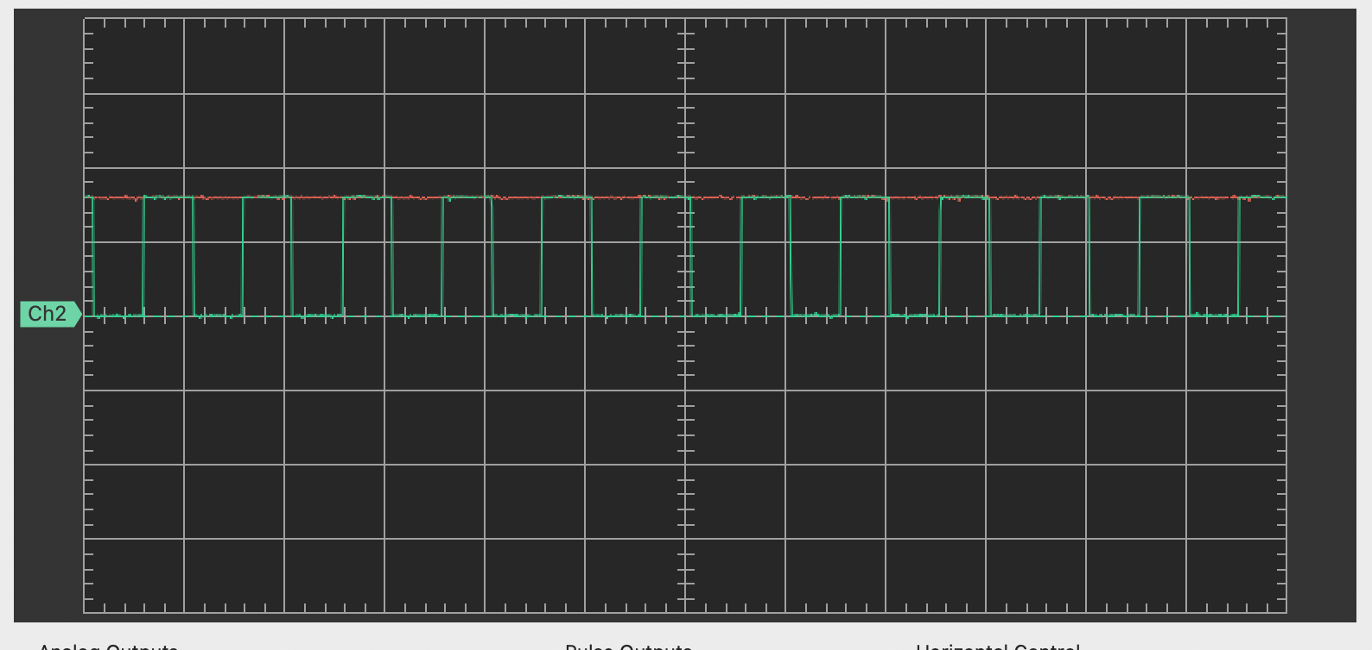

PR3 = 48MHz/20kHz - 1

>> PR3 = 2400 - 1

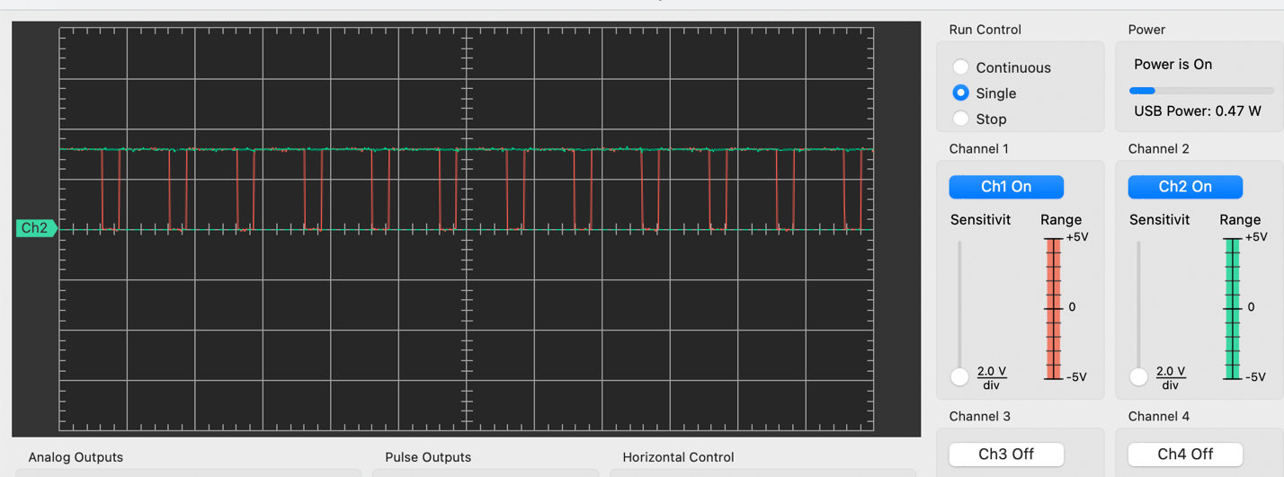

Ch1 OC1 waveform

Ch2 sensor output

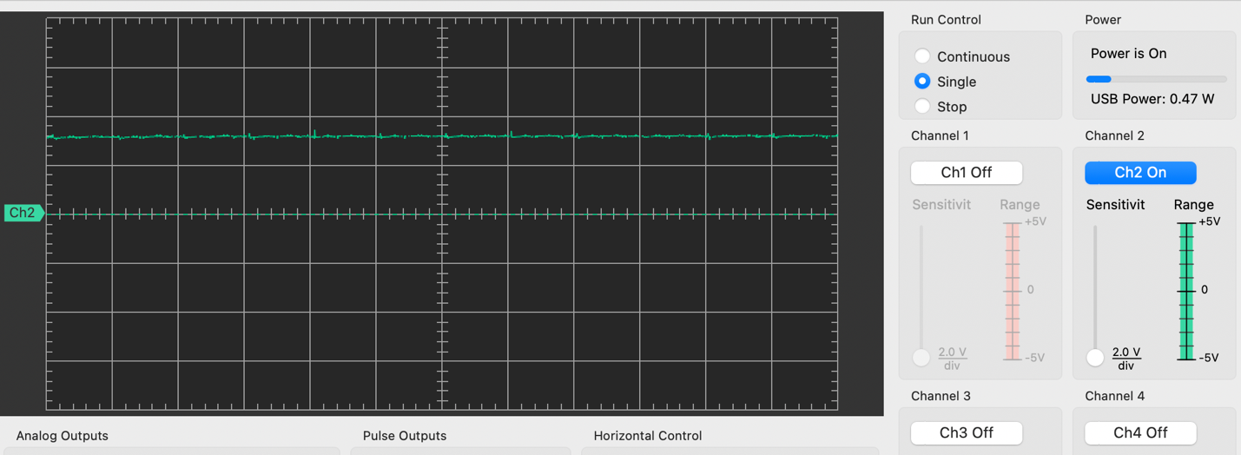

Ch2 without capacitor

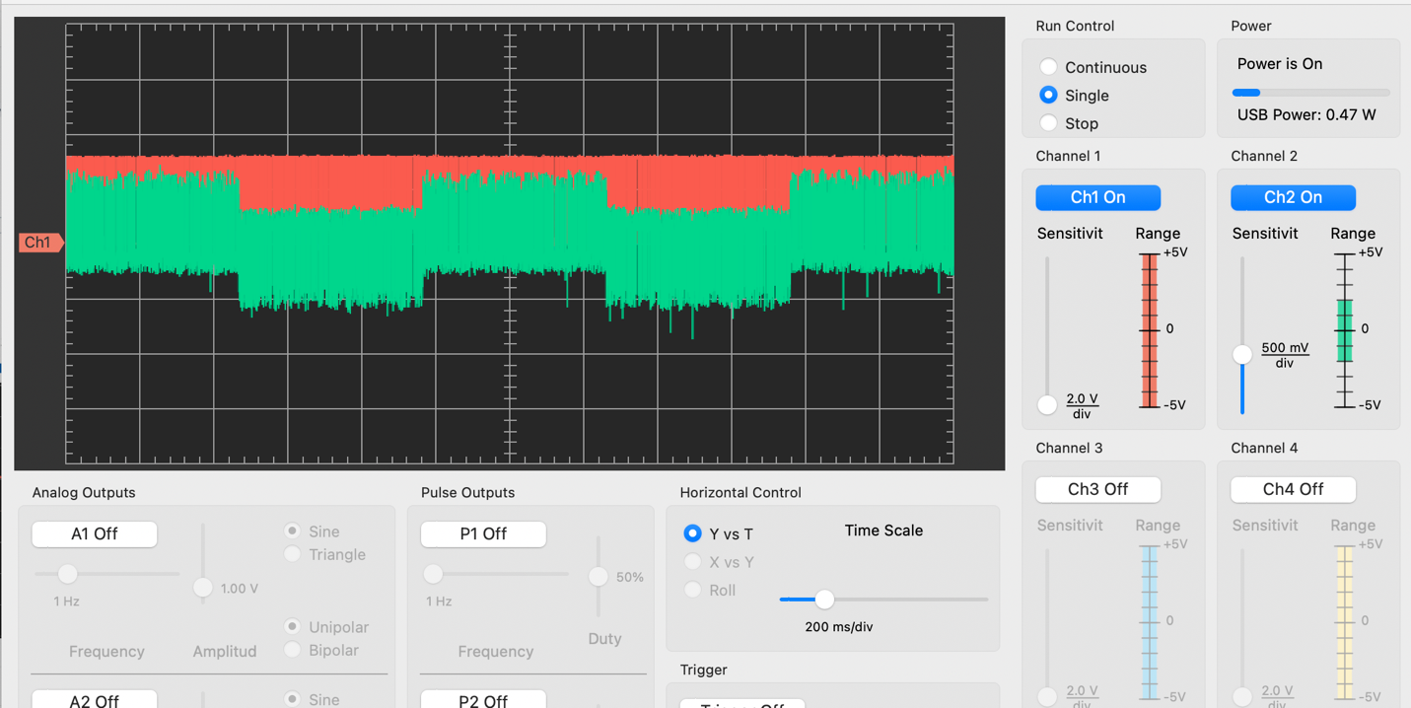

Ch2 Vout